Correlations between Genome Size and Speciation Rates in Gymnosperm
Alexander Cole Stiltner
WVU Tech
Dr. Johnathan Mitchell
BIOL – 461

Abstract
The purpose of the paper is to investigate if genome size has a correlation between the speciation rates through mutations and look into understanding more about the purpose and function of noncoding DNA. Using data created by Gregory Stull from his study on gene duplication in gymnosperms, a phylogeny tree of the gymnosperm was constructed and used to calculate the speciation rates of each species (Gene Duplications and Genomic Conflict Underlie Major Pulses of Phenotypic Evolution in Gymnosperms, 2021). The speciation rates were used along with the C-values of the species to find correlation between speciation rate and genome size. The results from the Pearson’s correlation method show that there was little to no correlation between the genome size of the species and their speciation rates.

Introduction
An organism’s genome refers to the unit in which the entire set of DNA is found in the cell of the organism, and the organisms DNA holds the instructions of how the organisms needs to develop and function. How all organisms know how to become the organism that they are is through the instruction of DNA. How DNA gets its information on how to develop an organism is from the DNA being pasted down form the parent organism or parent organisms to the offspring. The DNA code that is made for the offspring is never exactly identical to the DNA form the parent or parents. Changes in the sequence can lead to mutations in the organisms and what all that has been described leads to the basic principles of evolution and how we understand it.
Speciation is an evolutionary process in which new species come into being. In this paper, species is defined as being a group of living organisms consisting of individuals that are capable of exchanging genes or interbreeding, along with the species having a principal taxonomic unit that is ranked below genus and denoted by the Latin binomial. How Speciation is formed is by some form of barrier or conjoint effort from multiple barriers that leads to a population of species to become two group that cannot exchange genes with one another. The barrier that causes the split can be caused by evolutionary forces which are genetic drift, selection, mutation, and migration.
One of these forces that I want to test if there is a correlation with speciation rates and genome size. The genome size makes up the whole DNA sequence, however, in most organisms, a small percentage of that DNA makes up the coding DNA. The coding DNA is the sequences that code for proteins and control most of the development of the organism. Human’s coding DNA for example only make up about 8.2% of the whole genome (8.2% of Our DNA Is ‘Functional’ | University of Oxford, n.d.). The rest of the DNA is referred to as “junk DNA” or “noncoding DNA” because it was assumed that this DNA had little to no purpose. I wanted to test to see if larger genome size could have an increase on the rate of speciation in different species of Gymnosperm. This claim is based on the idea that the larger the DNA sequence is, the higher the chance of mutations to occur and cause the species to evolve into new species.

Methods
To test the correlation between genome size and rate of speciation, the data that was used was collected and reported by Gregory Stull (Gene Duplications and Genomic Conflict Underlie Major Pulses of Phenotypic Evolution in Gymnosperms, 2021). Stull’s data include a Phylogeny Tree of 1,055 different species of Gymnosperm and collected the C-value for 192 of the different species of Gymnosperm. The C-value is what represents the genome size of an organism and is a unit of mass. The mass for the genome size of a Gymnosperm is measured in picograms (pg). The data was transferred into R studio to plot the phylogeny tree. Using the R package speciesRaster, the DRstat command was used with the data from the phylogeny tree. The DRstat command is a code that uses the data that was used to make the phylogeny tree and calculate an estimate for speciation rates for each tip on the phylogeny tree. Each tip represents a different species of Gymnosperm.
Finally, the estimate of speciation rate and C-values for 192 species of Gymnosperm were transferred into Microsoft Excel, where graphs representing the estimate of speciation rates, C-values, and comparison of the two were made. With this data, the Pearson’s Correlation Test was used to determine the relationship between the estimate of speciation rate and C-values of the species.

Results
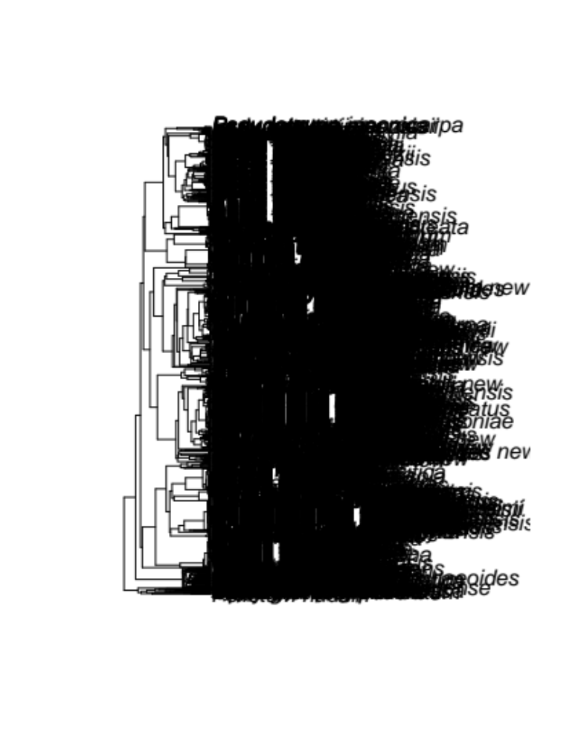
Figure 1: The phylogeny tree of the Gymnosperm that was constructed in R Studio and used to calculate the estimates of speciation rates.

Figure 2: This Bar graph shows the C-values (pg) of each of the Gymnosperm that represents the range of genome size in all the different spieces.

Figure 3: This bar graph represents the estimated rates of speciation for all the different species of Gymnosperm.

Figure 4: The scatter plot shows the relationship between the C-values and estimated rate of speciation for each species of Gymnosperm.
After the data was graphed, the correlation was calculated with the Pearson’s correlation coefficient. The Pearson’s method was the selected method of calculating the correlation because it measures the strength of the linear relationship between two variables. The Pearson’s coefficient ranges between 10 and -10 and the closer the number is to 0, the less the values correlate with one another, and a positive value represents a positive relationship, and a negative value represents a negative relationship. The Pearson’s method resulted in the Pearson’s coefficient being -0.257056883. In conclusion, the Pearson’s value being relatively close to 0, we can determine that the genome size of the Gymnosperm has little to no correlation on the speciation rate.
Discussion
Based on the data and tests that was conducted, we can see that there was not supporting evidence to prove a correlation between the genome size and rate of speciation. It could be argued that the Pearson’s method would not an accurate method to determine correlation because the Pearson’s method tests a linear relationship between the two and Speciation is caused by many different forces acting upon it. I still believed that the Pearson’s method was the correct method spite this argument because the goal was to find evidence of a correlation that is specifically between genome size and speciation.
Another question that comes from the results is some of the purposes for the noncoding DNA. For the purposes of noncoding DNA, tests and studies have shown that the “junk DNA” does have a purpose in the control of gene activity and help determine when certain gens are turned on or off. They have that role along with some regions being important for protein assembly (Shabalina & Spiridonov, 2004).
All in all, the results give incite on how a specific genome size does not has enough effect on mutation to cause a correlation between it and speciation rates. This concludes that further test can be done to determine what other forces such as genetic drift, selection, and migration have a larger or smaller impact than mutation along with other factors that can affect mutation rates.

